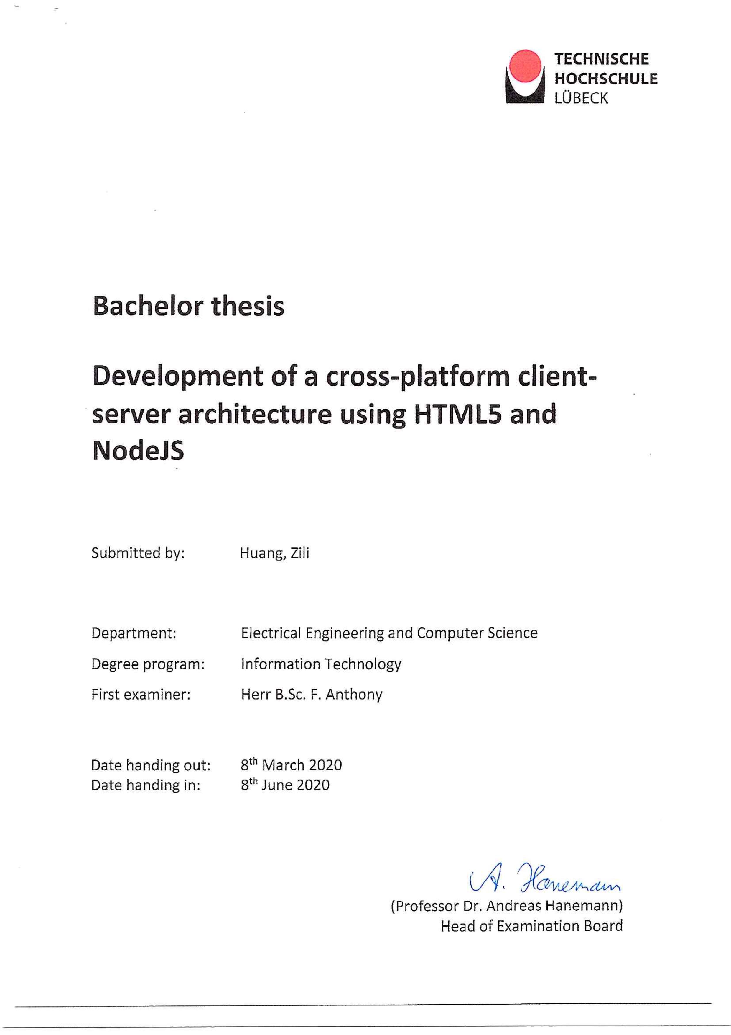

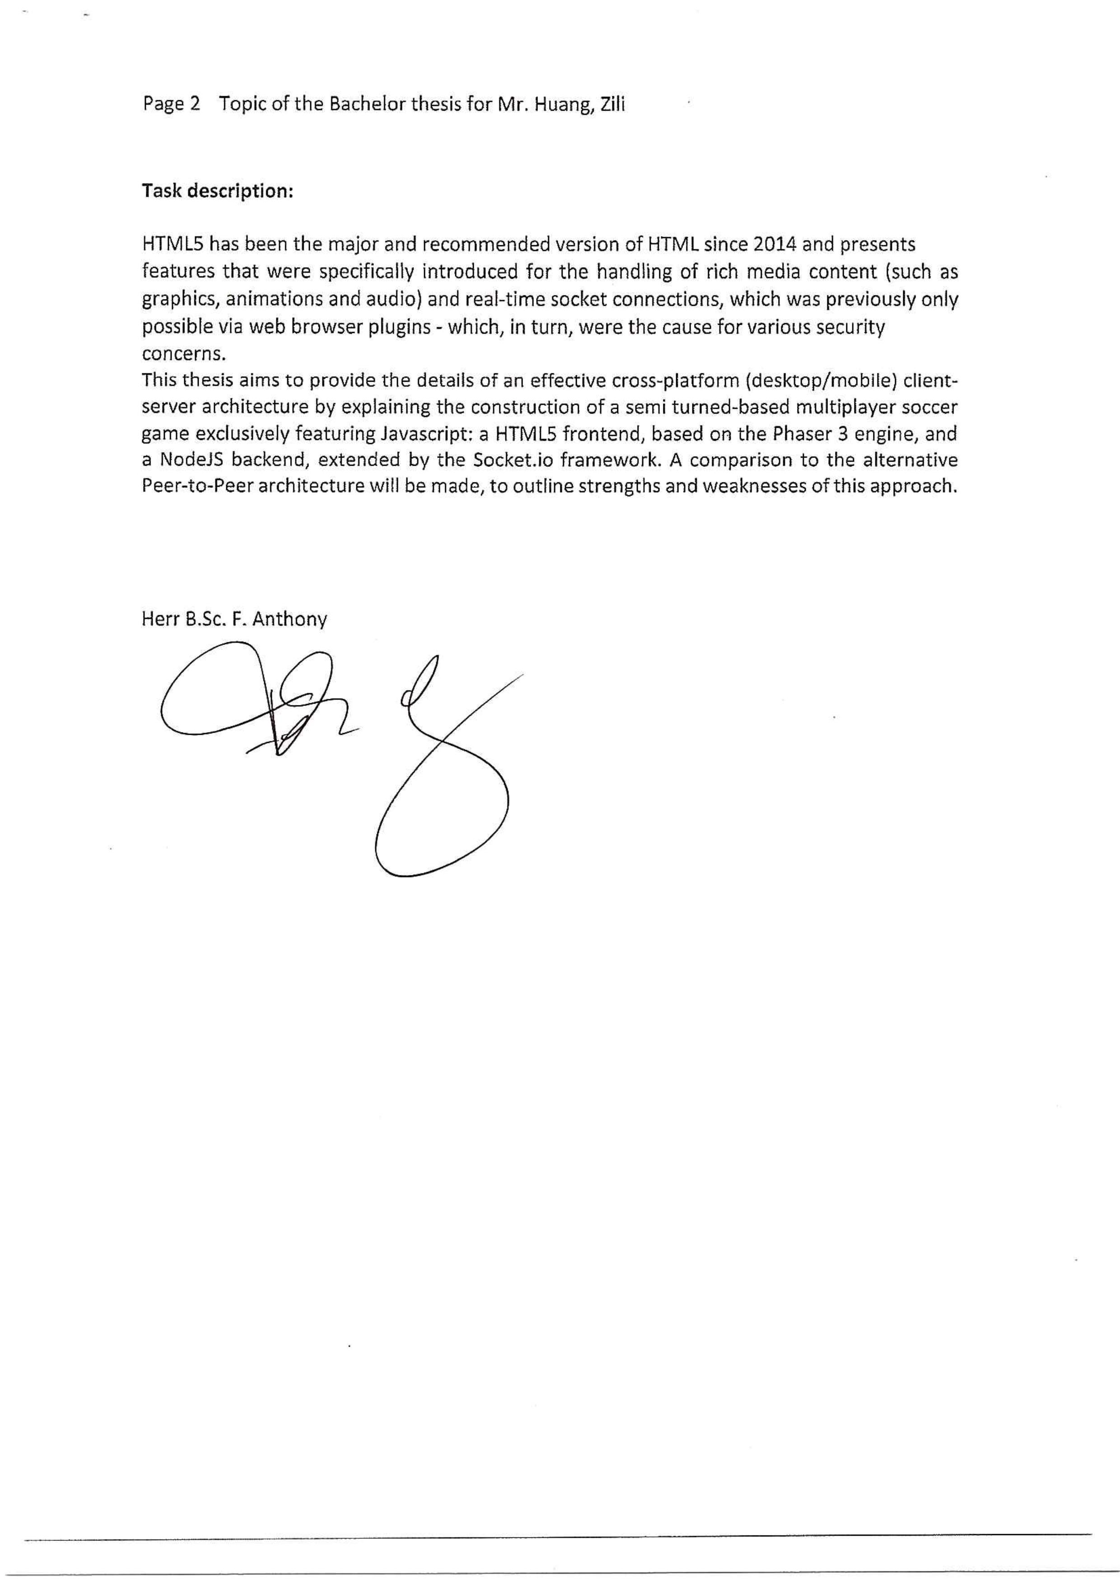Task Description

Declaration of the Candidate

Abstract

The purpose of this thesis is to develop an effective cross-platform client-server architecture. A semi turn-base multiplayer soccer game exclusively in JavaScript was constructed to provide the details on development. The thesis project includes three attempts on the implementation, and each of them improved from previous attempt. A questionnaire was distributed to usability testers to evaluate the complete application and raise areas for enhancement. And the collected data showed a high review on the network structure of the game, specifically for a cross-platform web application based on web browsers. The results provide some support on the convenience of the architectures with NodeJS and HTML5 developed in the thesis, especially in the practical use of a low-cost cross-platform project that demands interaction or cooperation between users.

Table of Contents

Task Description 2

Declaration of the Candidate 3

Abstract 4

Table of Contents 5

1 Introduction 7

1.1 Background 7

1.2 Introduction 8

1.3 The techniques used in the thesis 9

1.3.1 Phaser 3 9

1.3.2 Express 9

1.3.3 Socket.IO 9

1.3.4 jsdom and node-canvas 10

1.3.5 Path and datauri 10

1.3.6 Electron, electron-packager, and OS 10

1.4 Thesis structure 11

2 Design Phase 12

2.1 Design 12

2.1.1 Client Design 12

2.1.2 Server Design 12

2.1.3 Game Design 13

2.1.4 Alternative Plan 14

2.2 Feasibility test 15

2.2.1 Chat room 15

2.2.2 Arcade Physics from Phaser 3 17

3 Implementation 19

3.1 First Attempt 19

3.1.1 Server programming 19

3.1.2 Client programming 22

3.1.3 Issues and solution 25

3.2 Second Attempt 26

3.2.1 Server programming 26

3.2.2 Client programming 29

3.2.3 Issues and solution 30

3.3 Third Attempt 31

3.3.1 Server programming 31

3.3.2 Packaged application 33

3.3.3 Issues 33

4 Evaluation 35

4.1 Usability test 35

4.1.1 Test method 35

4.1.2 Test Result 35

4.1.3 Analysis 37

4.1.4 Improvement 37

5 Conclusion and Outlook 38

5.1 Conclusion 38

5.2 Outlook 38

Acknowledgements 40

References 41

Appendix 43

List of Figures 43

Usability Test: Instructions 44

Usability Test: Questionnaire 44

1. Introduction
   1. Background

With the growing network construction in modern life, the demand of using fragmented time with mobile devices is raised (*source request*). Increasing games with the names end in “.io” on Google Play and various mini games on WeChat, which allow users to spend spare time on online mobile games easily when they are taking public transportation, waiting for others, or even staying in restroom, represent the trend of making the most of fragmentation time on the Internet. A large part of these mobile games are multiplayer games that need installed apps or single-player games run by the web browser (*research request*). Few online multiplayer games can be simply accessed by web browsers, and a small share of them handle relatively much data processing, e.g. physics engine and rich media transmission. Under these circumstances, using existing techniques to implement a cross-platform and browser-based web application with distributed computing to manage data is a potential attempt.

In this bachelor thesis, HTML5, NodeJS, and distributed systems (mainly client-server architecture) are used as the core of the application implementation.

The 5th version of Hypertext Markup Language (HTML5) has been the major and recommended version of HTML since 2014, which improves the ability of handling multimedia and graphical elements. Meanwhile, new features of HTML5 allow devices with low computing performance, such as mobile phones, can run relatively complex web applications on a HTML5-supported web browser. In this situation, increasing frameworks based on HTML5 can be run on both mobile and desktop devices.

Node.js® is a JavaScript runtime environment that allows developers to write code for servers using JavaScript instead of learning another server-side language. By using V8 JavaScript engine from Google Chrome, NodeJSperforms great and is well compatible with ECMAScript standard, which standardizes JavaScript. On an account of being an open-source and cross-platform environment, Node.js® owns a massive number of libraries that are free to use, which in turn makes programming server-side JavaScript codes more convenient. [1] Implementing server with NodeJS lowers the requirements for making an independent and small web project by only mastering in JavaScript.

Distributed system still plays an important role in web application deployment. It is often used to decrease the cost of the network or tolerate more individual failures in a system. Comparing to peer-to-peer architecture, client-server architecture does not require clients to share resources with other clients, while it also has a comparatively simpler network structure than n-tier architecture (*source request*). Its clients are mainly responsible for displaying data requested from the server and sending input data collected from users back to the server. As a result, the applications using client-server architecture have less load on clients, and thus are more capable of operating on various devices, especially devices with weak computing power.

In conclusion, combination of HTML5 and NodeJS with a client-server architecture enables both weak-computing-power devices to run cross-platform project without much effort and presenting the similar performance.

At present, the games on Google Play, WeChat, or other similar platforms have already had a stable structure that allows users to play online during fragmented time effortlessly, but as mentioned in the previous paragraph, only a handful of them can achieve multiplayer and running with the web browser on a mobile phone at the same time. Among those games, online board games are most likely to be a cross-platform multiplayer game that can be run via not only installed application but also web browsers. For example, “Majsoul”, a Japanese Mahjong game, can be played by either using web browsers on PC and mobile phones, or app on mobile phones, which is a customized and packaged web browser. However, “Majsoul”, and many other cross-platform online games, does not contain complex data computation like physics calculation that will be used in this thesis project. Beside these, there is one project that has close topic with this bachelor thesis. Its topic is “Phaser 3 - Real-Time Multiplayer example with Physics” [2], which is one of the rare and shared examples that focus on calculating physics with Phaser 3 on server. The differences between this project and that are the programming language and multiplayer. The thesis project will use JavaScript and allows multiplayer instead of using TypeScript and being single-player.

* 1. Introduction

The goal of the thesis is to construct a distributed computing application with a webpage client based on HTML5, a server built on NodeJS,and using client-server architecture as network architecture. The clients of this application are supposed to be connected via web browser on both PC and mobile phones, and users can access the client by simply entering address in URL bar of the browser. In this way, downloading the full installation or compressed package is not necessary, which simplify the usage of the whole application.

As the current mainstream HTML version, HTML5 supports more types of element content, which allows it to accept more external frameworks or plugins, enabling more complex operations and programs in the webpage than the previous generation. Besides, HTML5 is also optimized for low-performance devices, which lays the foundation for applications to be used across platforms. Apart from that, as the cross-platform application requires a smooth run on less powerful devices, the use of a client-server architecture can minimize the workloads of data processing on clients, and thus enable the application to run across platforms well. To simplify the programming process of this application, NodeJS is selected so that the programming language of both client and server can be JavaScript. With this feature, it is very convenient to convert client-side code into a server-side one to reduce the workloads on clients when encountering a client-data-processing bottleneck, which greatly reduces the time on refactoring codes comparing to using two or more different languages for client and server.

This thesis aims to provide the details of an effective cross-platform (desktop or mobile) client-server architecture by explaining the construction of a semi turned-based multiplayer soccer game exclusively featuring JavaScript: a HTML5 frontend, based on the Phaser 3 engine, and a NodeJS backend, extended mainly by the Socket.io framework. A comparison to the alternative Peer-to-Peer architecture will be made, to outline strengths and weaknesses of this approach. Through the multiplayer game developed and tested on this thesis project, a better understanding on whether a webpage application based on HTML5 and used client-server architecture is capable of cross-platform usage can be comprehended. Issues met during the thesis and corresponding solutions can be useful examples or one of the possible methods for the further topic-related projects.

* 1. The techniques used in the thesis

For the purpose of programming a cross-platform multiplayer game, despite HTML5 and NodeJS mentioned and introduced in the previous section, other libraries are used in the final application as well. Brief introductions are provided in the following sections.

* + 1. Phaser 3

Phaser 3 is a game framework built with HTML5 techniques, whose goal is to build powerful and cross-platform HTML5 games on browsers with ease. With the help of HTML5, Phaser 3 makes great use of the benefits of modern web browsers, especially on mobile. [3] It specifically focuses on the performances of mobile browsers, since any low-performance features will not be added into the nucleus. The Phaser 3 game will be rendered with either Canvas or WebGL, based on the support of current web browser, which increase the compatibility for various browsers on both desktop and mobile. Besides, the pointer class of Phaser 3 allows inputs from both touch-screen and mouse to work nearly the same, and even swap in the mid-game, which are perfect for a cross-platform game. Additionally, Phaser 3 has two built-in physics systems: a highly light-weight AABB (Axis-Aligned Bounding Box) library for perfect performance on low-power devices called Arcade Physics, and a full-body third-part system for vast but precise physical phenomena simulation named Matter Physics. [4] However, the HEADLESS renderer mode is the most important feature used in the thesis that allows Phaser game to run without rendering, although the support of canvas is still necessary.

* + 1. Express

Express is a concise and flexible NodeJS web framework that provides a series of features and HTTP methods for developers to build various web applications. Express can handle various HTTP verbs in separate routes, use plenty middleware packages maintained by Express team or third party simultaneously to solve numerous web development issues, and create dynamical HTML pages for browsers to display. Through calling the only built-in middleware, ‘express.static’, Express can server different static files, such as JavaScript files, images, and audio files, from multiple directories with optional path prefix, which allows web applications to use local files.

* + 1. Socket.IO

Socket.IO is a library that achieves real-time, bidirectional, and event-based communication between the browser and the server. It consists of a NodeJS HTTP server and a JavaScript client library for the browser. Main features used in the thesis include reliable bidirectional connection, auto-reconnection and disconnection support, and wide browsers support. Although Socket.IO uses WebSocket as a transport when possible, some metadata is added to each packet for efficient transmission, yet it means that a WebSocket client cannot connect to a Socket.IO server, vice versa. In return, compatibility is massively increased by starting a connection as xhr-polling, and switching to WebSocket later if the protocol is supported by current web browsers. [5] Socket.IO allows developers to customize the events for triggering and responding from both sides along with a serializable data. Despite of several predefined event names, this feature makes communication events more scalable and distinguishable.

* + 1. jsdom and node-canvas

jsdom is a JavaScript library of the WHATWG DOM and HTML Standard particularly for the utilization in NodeJS. Its target is to “emulate enough of a subset of a web browser to be useful for testing and scraping real-world application”. By instantiating a JSDOM object, dozens of attributes and functions from the DOM APIs can be used in a NodeJS application. Apart from that, jsdom also allows running internal and external JavaScript codes by using <script> tag or methods from DOM with same effect. [6] The most notable capability of jsdom during the thesis is to simulate as a visible browser and provide canvas tag via including other canvas package. Under this circumstance, node-canvas, which is an implementation of the Web Canvas APIs based on Cairo (a 2D graphics library) for NodeJS, is chosen [7].

* + 1. Path and datauri

The path module in NodeJS allows the usages of file or directory paths in application. [8]

datauri is a NodeJS library used to generate data URI scheme to import data to web pages like external resources [9]. It is required in the application for compensating the unimplemented Blob URLs methods in jsdom. In this case, ‘URL.createObjectURL()’ and ‘URL.revokeObjectURL()’ are necessary for Phaser 3 to build instances with strings containing a URL, such as images and sprites in Arcade Physics.

* + 1. Electron, electron-packager, and OS

Electron is a framework made by GitHub, which allows the developer to build desktop applications with web technologies, such as JavaScript, CSS (Cascading Style Sheets) and HTML. Many famous programs like Atom, Visual Studio Code and WhatsApp are mainly or partially made with Electron. The NodeJS libraries and the Chromium kernel are integrated into Electron for the purpose of running and building across platforms, including Windows, Mac, and Linux. [10] A simple web application can be turned into a native program by adding electron libraries into node modules, changing a few codes for starting application with Electron instead of NodeJS and adjusting the structure to suit the requirement of Electron.

electron-packager is one of the official recommended tools for packaging the Electron applications with selected node modules through command line or JavaScript codes. It allows developers to “generate executables or bundles” for Windows, macOS or Linux. [11]

The os module in NodeJSprovides functions and properties that are relevant to the current operating systems [12]. For example, it is used to get the local IP address of the server with methods “os. networkInterfaces()”, which works similar to “ipconfig” on command line.

* 1. Thesis structure

The main content of the thesis includes five chapter. The first one, which is this chapter, mostly introduces the background and information around the thesis topic along with a detailed introduction on techniques used in the thesis project. The following chapter focuses on designing the application to achieve the thesis target and testing the feasibility of the design. The third chapter involves the process of implementing the application and the issues met during the implementation. Each of the three attempts tries to solve the raised problems from user’s tests or previous attempt and improve the quality of the application. The fourth chapter evaluates the application from the second implementation through a usability test with thirteen applicants, thus improving the third implementation with its feedback. The fifth chapter concludes the thesis and looks ahead for further enhancement on the thesis project and more practical usages on thesis topic. The chapters following the main content are acknowledgements, references, and the appendix involved details of used figures and usability test.

1. Design Phase
   1. Design

For fully preparation on the topic, a simple design phase was processed before the programming codes. It covered four parts, including designing a webpage that can be operated via various web browser on different devices, designing a server that supports client-server architecture and bases on NodeJS, formulating a basic game template and its logical rules, and researching an alternative plan for unexpected situation. To shorten the contents, the instances of football and players in the game will be referred to ‘objects’ when discussing on the client.

* + 1. Client Design

Since the purpose is to make a cross-platform webpage game, the game framework running on the client needs to be performed well on both mobile and desktop browsers. Fortunately, Phaser 3 has fully considered and utilized the advantages of HTML5 on weak computing devices, and can adapt to distinct calculating power on different platforms. By configuring the configurations when declaring a new Phaser 3 game instance, Phaser 3 allows the game to resize with defined ratio and center itself to adapt various size of the screen. This eliminates the hassle of setting separately in the HTML code for different types of web browsers, and thereby enhances the compatibility with various devices.

Phaser 3 framework includes two physics systems, which are Arcade Physics and Matter Physics. On the one hand, Arcade Physics is implemented by the developer of Phaser with AABB and bounding spheres algorisms. It only supports simple physical calculations, such as velocity, acceleration, friction, and collision computing of rectangles and circles, but it has a very fast calculation speed as a compensation. On the other hand, Matter Physics is a third-party physics engine, named Matter.js, integrated into Phaser 3. It has more powerful physical algorithms, making the physical performance of objects very close to the real world. As a result, it runs slower, but can achieve many realistic physical actions that Arcade Physics is not possible to do, e.g. impact of spinning on movement, elastic deformation and collision, and polygonal physical body [13]. Since the game only needs the collision calculation of circles and rectangles, Arcade Physics was chosen in this project to save computing power.

* + 1. Server Design

After researching diverse tutorials relevant to Phaser 3 game implementation, the server decided to utilize Express to help create a HTTP server and use Socket.IO to achieve real-time communication between clients and server. The collaboration of NodeJS, Express, and Socket.IO is so mature that enough tutorials and discussions can be referred when programming and encountering server-related issues. Web Real-Time Communication (WebRTC) protocol, which allows establishing peer-to-peer communications between RTCPeerConnection instances in different browsers [14], was considered as a possible solution. Additionally, there are many libraries on npm that allow NodeJSapplication to establish peer-to-peer connection. However, comparing to Socket.IO, which mainly uses WebSocket protocol to establish communications, WebRTC-relevant libraries lacks both tutorials or discussions and stable compatibility. In some cases, a forwarding server that requires Socket.IO library is still needed to start the connection between peers. As a result, the learning cost of the codes is higher than building a client-server architecture.

In addition to the determination on necessary techniques, the server will also store a logic for a non-character player (NPC) to take over the player’s control if there are not enough users to control all players. It should be able to “attack” or “defend” according to the situation on the football field, while it may not shoot the football so precisely that users on opponent team have little chance to beat NPC. The detailed logic is introduced at the end of chapter 3.1.1.

* + 1. Game Design

The game is mainly composed of two parts, one is the game area in the center of the screen, presenting the main game content, and the second is user interface (UI), used to place buttons and display game-related text and images.

Before every design on the game starts, basic game rules had to be set up. Traditional soccer games used to be a real-time game that both users control their team at the same time, but it would be impossible for mobile and desktop users to compete against each other. So, the target of the thesis is to make a turn-based game which allows mobile devices have same performance as desktop. In this case, the game is similar to the billiards but with the rules close to soccer, and hence the shape of players is simplified to a circle. The player should be able to control the movement direction by dragging an arrow to visualize user’s input remarkably, since it is not convenient to notice the value of input under the finger on a touch screen. With regard to the number of users, the game is determined to let four users to control two players each in one game as a result of the desire to test the potential of client-server architecture, the limited screen size of many mobile devices, and the probability of having more fun with more choices in every round. Finally, the goal is decided to be inside the football field due to the limitation of the impossible polygonal physical body of Arcade Physics. Because the football field can be predicted to be small, the goal should not be much larger than the player. For the same reason, the teams of the first two users who started the round should be placed away from the football to prevent scoring with the first shot.

The size of the game had to be decided after the design of game rules. At present, the most popular ratio of the screen on desktop is still 16:9 and many all-screen smart phones tend to have a longer ratio than 16:9 to make up the notch. Considering the size of address bar above the web browser, a ratio longer than 16:9 would be a good choice to make full use of the space on browsers. In this case, the ratio with 2:1 and the resolution of 1200*600 is determined. With the help of Phaser 3 setting, the game can zoom in and out to fit the size and resolution of current browsers. As for the football field, which is the main input area, its size cannot be so big that GUI would not fit, while a small size could make it hard to input the proper command. In the end, the football field is chosen to be 800 pixels wide and 400 pixels high after many drafts, and is place in the lower middle. To achieve the goal of having enough moving space for eight players and one football, the player is set to be seventy pixels in radius, and the football is relatively smaller, which is fifty pixels in radius. In this case, the width of the goal is fixed to be 100 pixels. After applying the rules to player’s positions and plenty minor adjustments, the final design on football field is made, and shown below.

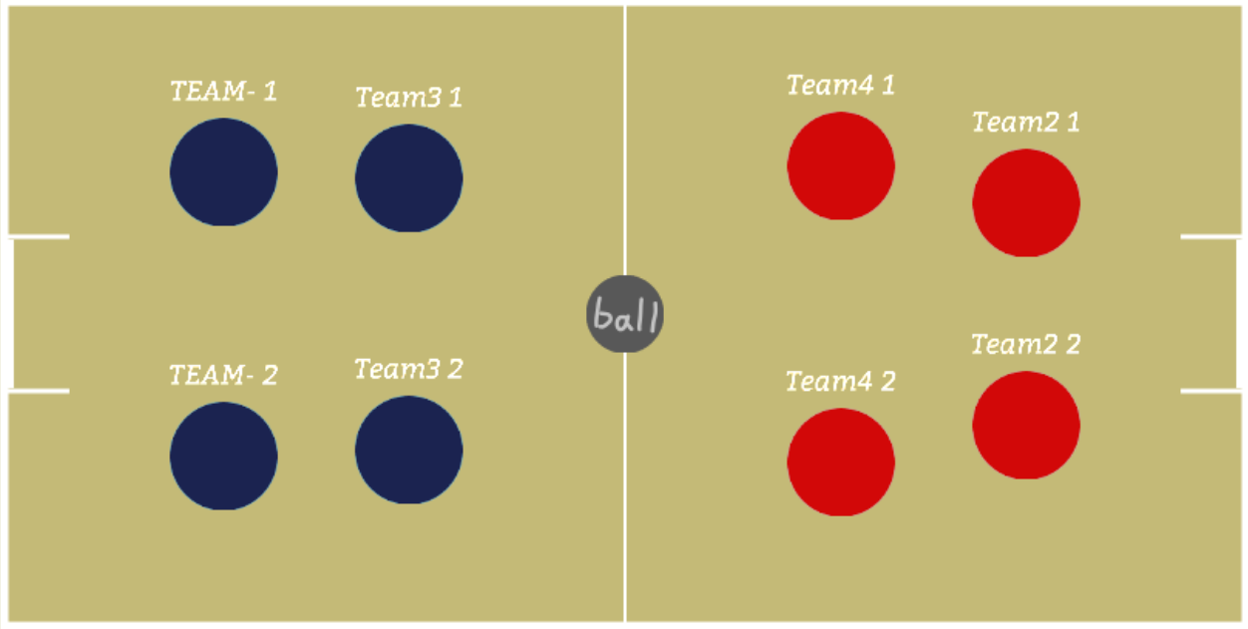

Figure : The football field

Finally, the rest of the space is used to place the UI. The notification area at upper right corner should include useful information for user. It needs to display the status of the users like “A user connects” or “A user disconnected”, and the notices of game status such as “Game starts” or “Your turn”. The top of the screen will display the current score, while the upper left corner will show the title of the game. On both sides of the screen will lay the buttons for uploading input and starting the game, which may also show the number of current connected users. As for the animation for celebrating the goal, it will show in the middle of the screen when any user goal. The examples of the design are listed below.

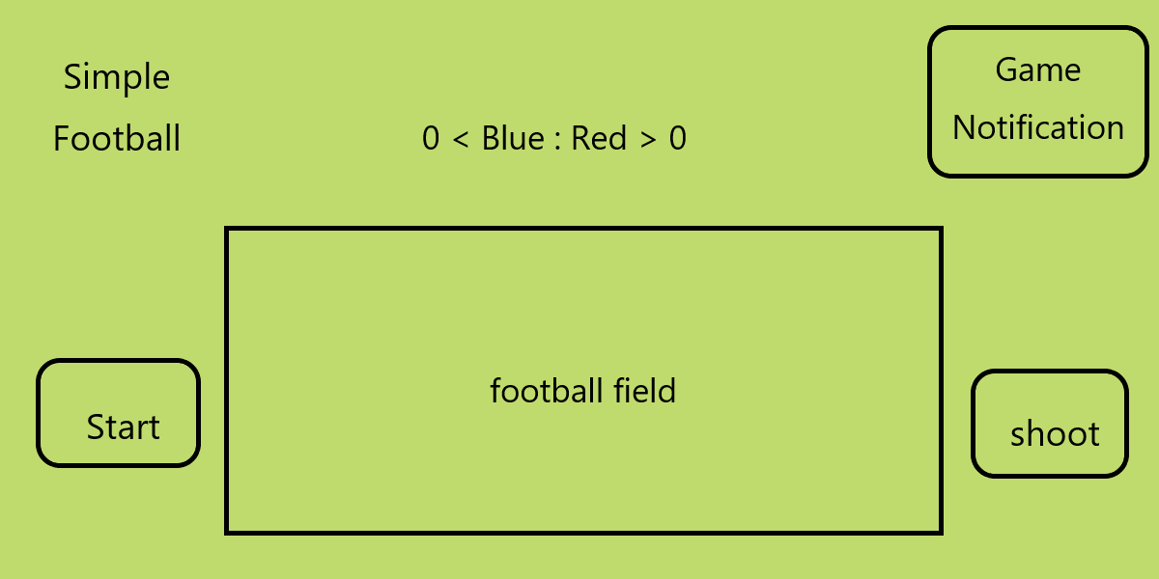

Figure : The total UI



Figure : The goal animation

* + 1. Alternative Plan

Since the consistency of the physical calculations with Arcade Physics on different clients cannot be guaranteed, and the probability of successfully eliminating errors on positions with location synchronization solution is not sure, a backup plan is designed to replace the original one as fast as possible. In the alternative, the server will not broadcast every user input, but directly broadcast the specific location of all movable objects in each game update loop. Then the clients will straightly place or move corresponding objects on received positions. In order to reach this effect, the HEADLESS mode of Phaser 3, which is used to run Phaser 3 game without rendering graphics, is necessary. And detailed researches [15] [16] suggest that more libraries are required to meet the demand of specific variables for Phaser 3 to run at server. Additional libraries include node-canvas, jsdom, and datauri, as mentioned in chapter 1.3. meanwhile, the most parts of the codes will be reused to save time and reduce the difficulties in refactoring and rebuilding.

* 1. Feasibility test

In order to test whether the design will work, the feasibility test is planned. The test involves two parts. The first one focuses on the data transmission capability of the server built on NodeJS and its libraries. A chat room server will be built with NodeJS, Express, and Socket.IO and tested with its transmission latency and speed in sending rich-media files to verify how NodeJS performs under local area network (LAN). The second test concentrates on the performance of Arcade Physics from Phaser 3. After the game prototype is completed, the test will be carried on by sending the same input to different clients through server at the same time, and the target is to analyze whether odd results from the physics computing, which could be an excessive difference in objects’ positions, exists. This test will determine how clients and server communicate each other.

* + 1. Chat room

A completed chat room is built with two parts, one is the server and the other is the webpage as the clients. The server is made with NodeJS, Express, Socket.IO, body-parser, and multer, and is responsible for broadcasting messages between different clients and storing pictures sent by the clients. Among those libraries, body-parser allows the HTTP server to parse POST request, and multer enables the client to send image files to the server. The client webpage mainly uses Ajax (Asynchronous JavaScript and XML) methods from jQuery and Socket.IO methods to send and receive messages. The detailed layout of the webpage is shown right.



Figure The file structure of chat room app

The structure in this thesis is all built with ‘tree-node-cli’ module [17].

The test method is to calculate the time required for the client to send a picture or texts to the server and the time required for the server to return the results to one client. By uploading the data to chat room server, including picture, text, a customized cookie, and a timestamp that recorded the uploaded time, via Ajax POST method, the server calculates the time gap between uploaded time and received time and send it back to clients via Socket.IO methods with sent time and received cookie. Then each client will calculate its own second time gap and display the cookie, the first time gap, and the second time gap on the webpage. The following codes and pictures show how the chat room works.



Figure : Codes for transmitting images



Figure : Codes for Ajax method

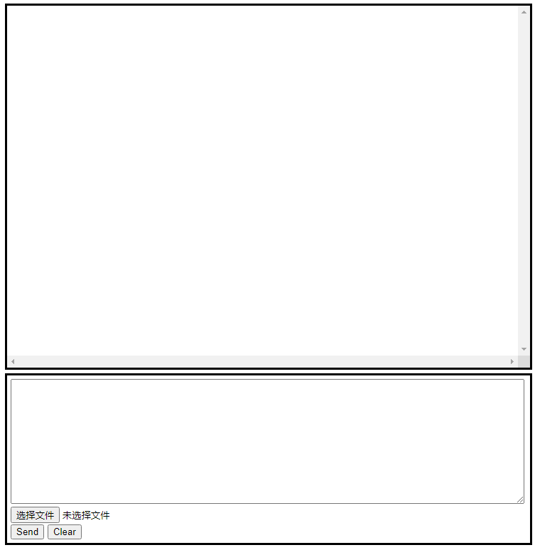

Figure : Chat room layout

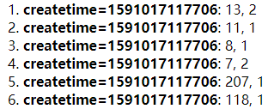

Figure : Time gaps

(The first is Ajax, the second is Socket.Io)

As the screenshots show, the two time gaps between sending and receiving data without rich-media files are really small, especially when using Socket.IO methods. Meanwhile, the time gap with a big picture (approximately 2 MB) is relatively larger due to the network limitation. And the most important thing is no packet loss during the whole test. The result is cheerful since no continuous media transmission is required in the game design, which further increase the reliability on message changing.

* + 1. Arcade Physics from Phaser 3

When the test was executed, the game had completed the basic construction of the server and simple game setup. The server was able to identify and record the login data and operation of different users, which could calculate the initial velocity of the user-selected player according to user’s input on client and broadcast the result to all clients. Meanwhile, the client was able to collect user’s input on player’s direction and moving force to send to server, and use returned result to set initial velocity of the player. The game area could not detect the event of goal, but only the collision among players, ball, and the bound of game area.

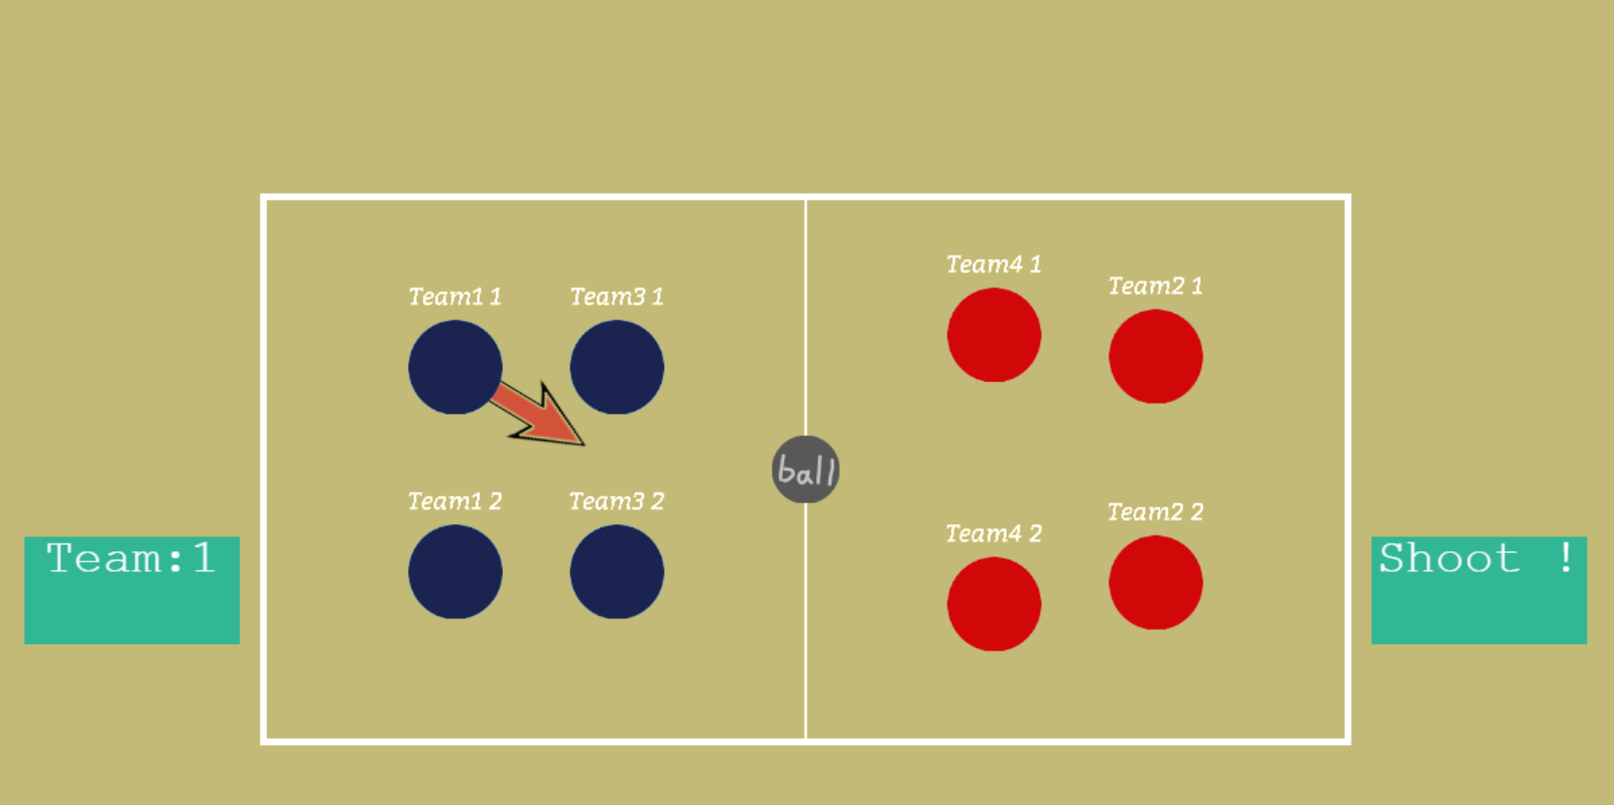

Figure : Current game UI status

The test methods include the following step. First, after the clients run the result from the server and detect that all objects stop moving, they send a message to the server, which is an array that contains all positions of players and ball. Then the server will compare all clients’ positions and output the result (true/false) in command line. At the same time, the client will show the first player’s location at the top-left corner of the display area, which could be used to contrast the locations of all clients directly.

Test result indicates that the differences in final objects’ positions between two clients on different devices are quite small. Though most of the outputs on command line are false, the divergence is always tiny and happens after two decimal digits. In this case, adding a simple function for computing the average positions of all connected clients and forcing them to synchronize before every round starts would be enough for the tiny deviation in this test. As a result, the communication method between clients and server was determined to be exchanging game status before and after a round to reduce transmission frequency, since Arcade Physics can output close and stable positions with the same input after a series of physical computing.

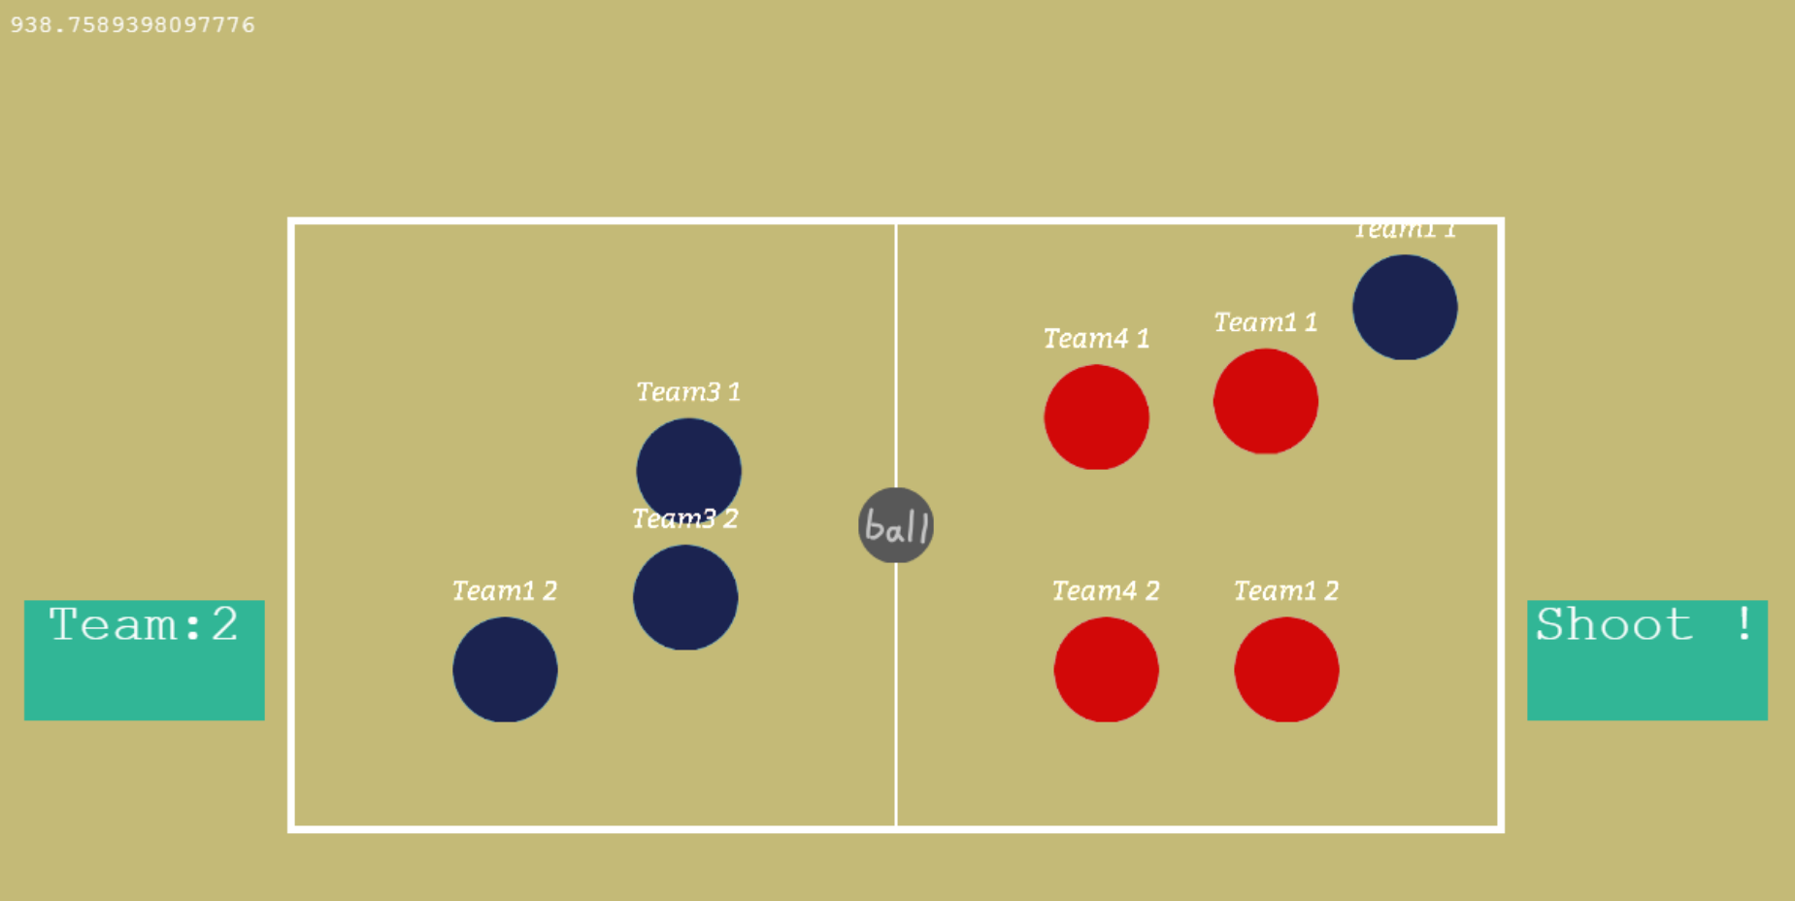



Figure : Two coordinates from two clients

Although Arcade Physics of Phaser 3 showed very close performances to the physical computing results on different clients in this test, as the client needs to process more data with growing game content, the differences between client’s results enlarged. This indicates that Phaser 3 still cannot reproduce every physics calculation results among clients with different calculation capabilities. The conclusion of this test may not take the impact of heavy load on the game update loop into consideration. Regardless of whether the same browser opens different webpages, different browsers open different webpages, or different devices open different webpages, there is a high probability that the differences in positions are so large that it cannot be eliminated by simply computing the average position.

1. Implementation
   1. First Attempt

The structure of the whole files is shown on the right side. Among those files and folders, ‘package-lock.json’ and ‘package.json’ are the configuration or instruction for using NodeJSthat makes the projects reproducible for others, while ‘node_modules’ folder contains both basic libraries and added frameworks of NodeJS required in the application. These three files remain the same usage in the following attempt and will not be mentioned in the following introduction.



Figure : The file structure of the first attempt

* + 1. Server programming

The server is programmed in file ‘server.js’. The code could be separated into several parts, including requiring NodeJS libraries, declaring essential variables, setting socket events with Socket.IO methods, and finally starting the server. In the first part of the codes, packages of Express and Socket.IO are required. Then the folder path of local files for clients to access and the file path of the main page are set.



Figure : Required modules



Figure : Define file path for client

Some global variables are declared in order to record users’ data and game status:

* ‘userNum’ is an integer with an initial value of 0, and records the number of clients currently connected to the server.
* ‘gameStatus’ is an object with four properties to record the status of game, including ‘gameStart’ for whether the game starts, ‘gameTurn’ for the number of game rounds, ‘gameScore’ for the game score and ‘waitNextTurn’ for whether it is waiting for the client to respond.
* ‘shootSpeed’ defines the half of the maximum initial speed that every player can move, which is 800 pixels per second, at server side. It prevents the possibility that modified client files cause all selected players on clients to exceed the speed limit.



Figure : The properties of ‘users’

* ‘users’ is an array that records the all users’ data from connected clients that are currently playing the game. The array item is an object with seven properties, and is made up of the socket id of connected client, user’s nickname, user’s team number, whether the client is ready to start the game, whether the client has ended the current round, which team achieves goal, and the position of all objects in this round.

The server contains a few events of Socket.IO for the communication between clients and server:

* ‘connect’ is a reserved event predefined by Socket.IO, and will be fired upon a connection from client. This event takes charge of the data update when a new client is connected. If this is the fifth or later connected client, the server will send an event called ‘over4’ to it; if not, the server will first update the number of connected clients, and then will trigger the ‘loginData’ event to the current client as well as send the present game condition. According to the contents returned by the client, the server will update the corresponding user nickname of users first. Then, If the current client is the first to connect, the server will additionally set all ‘position’ properties in ‘users’ to the position received from the client. Finally, the server will fire ‘currentStates’ event to current client with complete values of ‘users’, and ‘newUser’ event to rest connected clients with current client’s data in ‘users’.
* ‘disconnect’ is a reserved event predefined by Socket.IO, and will be fired upon a disconnection from client. This event will initialize every data of disconnected client in ‘users’, and broadcast the event called ’playerDown’ to the rest client(s). If the current server has no client connected, ‘gameStatus’ will be initialized; if not, the server will examine whether disconnected client has unfinished steps, and complete them if they exist.
* ‘toStartGame’ will be fired when a client is ready to start a game. The server will set its corresponding ‘startReady’ property in ‘users’ to true, and check whether all connected clients have sent this signal. If this is the case, the server will broadcast the ‘startingGame’ event and reset all ‘startReady’ properties in ‘users’ to false. If not, the server will broadcast the ‘waitingGame’ event with the number of ready clients and not assigned teams for clients to display.
* ‘toShootBall’ will be fired when the client, which is operating in the current round, determine to move the player. The data received from client contains the socket id, assigned team number, the player number and vectorized speed and force in a vector object of Phaser. The server multiplies the vector with defined ‘shootSpeed’ and broadcast it with other received data to all client within the ‘shootingBall’ event. Then the ‘waitNextTurn’ property of ‘gameStatus’ is set to true for state the status of waiting for clients’ responses.
* ‘toNextRound’ will be fired when all objects on one client have the velocity of zero. The server will set its corresponding ‘turnReady’ property in ‘users’ to true, as well as update the matching ‘position’ property. Then whether all connected clients have sent this signal will be checked. If this is the case, the server will check whether all received positions from clients are the same, and update all ‘position’ properties and broadcast ‘syncPosition’ event with the computed average position supposing the result is false. Afterward, the ‘goNextRound’ event is broadcasted with the values of ‘gameStatus’ and all ‘turnReady’ properties in ‘users’ and ‘waitNextTurn’ in ‘gameStatus’ are set to false. Additionally, the ‘gameTurn’ in ‘gameStatus’ will increase by one, and in case next turn has no user to operate, the function for simple NPC logic will be called.
* ‘toGoal’ will be fired when the client detects a goal event. The server will set its corresponding ‘goalMessage’ property in ‘users’ to received string, and check whether all connected clients have sent the same content. If this is the case, the server will increase the score of scoring group at ‘gameScore’ in ‘user’, broadcast the ‘afterGoal’ event with the values of ‘gameStatus’, and reset all ‘goalMessage’ properties in ‘users’ to false.

Furthermore, the server also has a function called ‘simpleAI’ for simulating users’ action to control the teams that have no user assigned. The basic logic of this simple NPC involves three steps. First, a random player number (0 or 1) will be selected, and the location of the player, the football, and the goal are obtained from the ‘position’ property of current turn’s team in ‘users’. Next, according to the relative position of the ball and the chosen player, the movement of the player is determined and the moving direction is calculated.



Figure : Compute the shooting angle in different conditions

On the one hand, if the player is between the goal and the football, the player will try to move closer to own goal. On the other hand, the player will decide to kick the football, if the ball lies between it and the goal. Under this circumstance, the coordinate of the ideal destination is computed by finding the point on the half-line, started at goal and passed the football, that is fifty-five pixels (the approximate sum of the radiuses of the football and the player) away from the football. Finally, the initial velocity is computed by sine and cosine function and the player number and velocity are returned in one object.



Figure : Compute final output velocity with trigonometric functions

* + 1. Client programming

The files of the client are stored under ‘public’ folder, and the detailed structure is shown below.

* The ‘assets’ folder holds all the font files, images, and JavaScript files that build up the game area.



Figure : The file structure of ‘public’ folder

In ‘bitmapfont’ folder, there is a texture file called “bitter.png” and an XML file called “bitter.xml”, which are used to render less flexible and faster texts objects in game as the font is determined. The free font “bitter” is used to create these bitmap text datafiles.

In ‘control’ folder, four JavaScript files control creating the customized Phaser 3 objects. “football.js” and “player.js” separately extend the “Phaser. Physics. Arcade. Image” class to customize an image with a circular Arcade Physics body to act as a football or a player. “playGround.js” creates a class to set up a background of football field as an image and two goals as Arcade Physics images. “team.js” creates a class by instantiating two players as a team and adding an arrow image for controlling the force and direction when moving the players. The class records the assigned client’s socket id and team number and has the only function that fires ‘toShootBall’ event to move the player.

In ‘image’ folder, eight images in png format are stored for client’s use in the game.

In ‘scene’ folder, “login.js” and “play.js” extend “Phaser. Scene” class and compose the game. Both enable users to input with mouse or touch on defined buttons, areas, and objects. “login.js” is a scene that forms a login page for user to type in their five-character nickname with twenty-six lowercase letters and hyphen and passes the nickname to “play.js” when starting it as the main game scene. “play.js” is the main game world that instantiates four teams, one football and the football field, as well as enables and tracks the collisions among them. If the football is overlapped the goal, the ‘toGoal’ event is triggered. It also records the game status of this client and uses Socket.IO methods to communicate with the server. In the update loop, client will continuously check if all objects are stopped when the game is start.

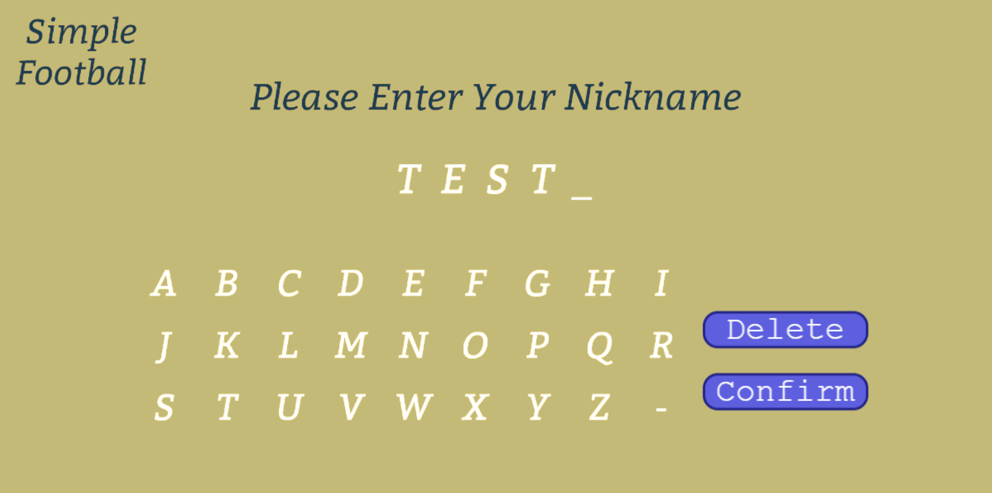

Figure : Login Page

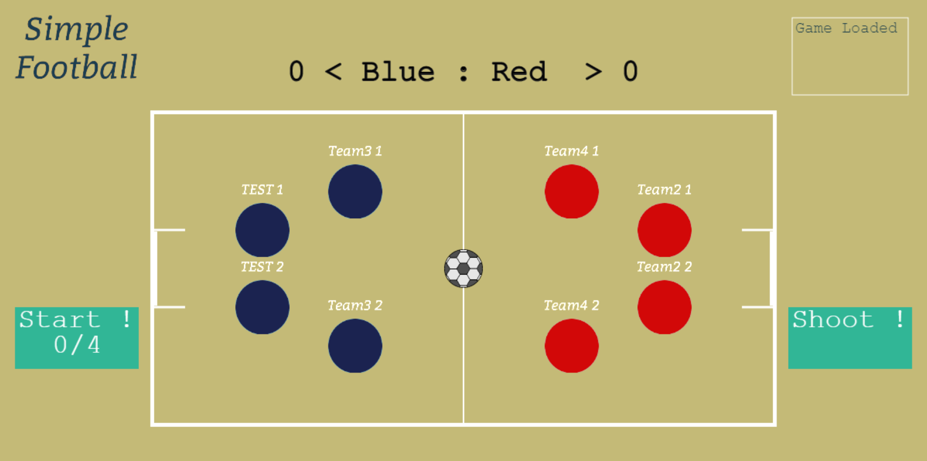

Figure : Game Page

* The ‘lib’ folder contains the build file of Phaser 3, which allows user to start a local multiplayer game without the Internet.
* The “index.html” is the main page that will be displayed to the user, and the place where the game is rendered. It imports the packages of Socket.IO, Phaser and “main.js” in sequence to prepare the libraries needed for the game.
* The “main.js” is where the game instance of the Phaser 3 is declared. In this file, the initial configuration of the game is set and passed to the created game. The game is adjusted to choose Canvas or WebGL renderer automatically, have an initial size of 1200 * 600, use Arcade Physics by default, limit the graphics update loop to twenty-five frames per second, resize and center according to the screen size automatically, and use the two given scenes to run the game. The LoginPage scene will be called first when starting the game.



Figure : Phaser game configuration

User notification areas and buttons mentioned in design phase are also programmed, and function the same as the plans. Moreover, the client contains a few events of Socket.IO in “play.js” for the communication between clients and server.

* ‘loginData’ will be fired once when the server is aware of the connection of this client. The client will update the game status and objects’ positions if it connects first with received data. Then the nickname of the user and current positions of all objects will be uploaded to the server. Additionally, the user notification will also be updated if the game has started when client connects.
* ‘currentStates’ will be fired once after the server receives and processes the data in ‘loginData’ event. The client will update the ‘userSocketID’ attributes of all four teams and the names above all players with the given values of ‘users’.
* ‘newUser’ will be fired whenever the server finishes updating the information of connected client. The client will update the ‘userSocketID’ attribute of the connected client and names above players of the corresponding team with the given data of ‘users’.
* ‘waitingGame’ will be fired when part of the connected clients is ready to start the game. According to this client’s status, the game will display different notification and show the number of ready clients.
* ‘startingGame’ will be fired once when all connected clients are ready to start the game. The first team will be set to be operational, and ‘gameStart’ will be turned to true which symbolize the start of game.
* ‘over4’ will be fired when this client is the fifth or later one to connect the server. The client will notice the user for not being able to join the game.
* ‘playerDown’ will be fired when a client is disconnected from the server. The ‘userSocketID’ attribute and player’s names in corresponding team instance will be initialized.
* ‘shootingBall’ will be fired when a client or the NPC at server decides to move the player and initial velocity is computed. The client will set the initial velocity of selected player and change the game status of the client to waiting for the signal of beginning next turn.
* ‘syncPosition’ will be fired whenever the server asks all client to synchronize each object’s position with received coronadites.
* ‘goNextRound’ will be fired when all clients are ready for next turn and the server requires all clients to start next turn. The client will synchronize the game status with server’s and change to the matching notification.
* ‘afterGoal’ will be fired when the server received all goal messages and confirms the goal. The client will synchronize the game status with server’s and restart the game.
  + 1. Issues and solution

During the early construction of the game, it was found that the objects’ positions between different clients were close but have tiny differences. Unlike gaps in the feasibility test (chapter 2.2.2), the x coordinates of the first player in the first team from two clients have a gap in single digits. By repeating the same input several times, the reason was revealed to be the minor divergences in computing the friction on each client, and thus the differences caused player to stop after different amounts of frames after it was moved. In order to solve the issue, a manual stop function would be called after any object speed was slower that 0.2 pixels per second.

The gap between positions had been reduced at that time. However, with the growing data computation on every client for the progressing programming, the light-weight Arcade Physics were making more glitches during the game. For instance, two players attracting together and spinning weirdly, which is the most serious one, happened if they hit each other in a slow speed. After the researching relative problems on the Internet, the solution on limiting frames per second (FPS) was found and used. The FPS of the client was limited to 30, and it also affects the number of the update loops in one second, which reduces calculation load on low-power devices as well.

After fully constructing the application in the first attempt, a small-scale test was made to examine the synchronization of the positions and application did not pass due to the Arcade Physics issues. Whatever devices were used to run the application, there was always one or more distinct gap between clients on different devices. As mentioned in the last paragraph of the chapter 2.2.2, the heavy load on client could the most possible reason for the gap between computing results, since both rendering and calculating took place at the same time. Under these circumstances, the alternative plan in chapter 2.1.4 was determined to be implemented.

* 1. Second Attempt

In the second attempt, on the one hand, the structure of server can be divided into two sections. ‘server.js’ is responsible to build the runtime environment of the server, while files in ‘physic_server’ folder construct a HEADLESS-mode Phaser 3 game that makes calculating physics on server possible. On the other hand, the structure of client’s files stays almost unchanged. The structure of the application in second attempt is placed on the right side.



Figure : The file structure of SimpleFootball app

* + 1. Server programming

Unlike what ‘server.js’ did in the first attempt, instead of declaring variables and setting socket event emitter, it also prepared the environment for running Phaser 3 game on server. Despite including the Express and Socket.IO packages, path module, jsdom package, and datauri package are required, whose detailed introductions could be found in chapter 1.3. Then the paths of local files are set in the same way. In the last part of ‘server.js’, a jsdom instance is constructed from ‘index.html’ introduced in next paragraph, which can execute external scripts, pretends to be a visual browser, and returns a promise object. In the following ‘then’ method, as mentioned in 1.3.4 and 1.3.5, URL.createObjectURL and URL.revokeObjectURL are created for running Phaser 3 engine successfully. Additionally, function called ‘gameLoaded’ is constructed for starting listening after the Phaser game on server is fully running, and the instance of Socket.IO is passed to jsdom with property named ‘io’. Eventually, all errors will be caught in the ‘catch’ method and output in the command line.



Figure Required modules



Figure Use JSDOM to make up missed methods

As for the ‘physic_server’ folder, its structure is shown on the right.

* The ‘image’ folder holds the images of player, football, goal net and goal post that will be used to compute the physical body of corresponding object in Phaser 3, and it also shares the same original files with client.



Figure : The file structure of ‘physic_structure’ folder

* The ‘js’ folder contains all JavaScript files that are needed to run the game.

The ‘lib’ folder holds the build file of Phaser 3.

In ‘objects’ folder, ‘ball.js’, ‘player.js’, and ‘team.js’ works the same as they did in the first attempt despite that codes are refactored and all input and decoration is deleted, as nothing will be rendered. Same rule applies on ‘goal.js’, which is a simplified version of ‘playground.js’ that only instantiates the parts of two-side goals.

And ‘main.js’ is the main game world that will run on the server. It stores authoritative configurations and statuses of the game, instantiates football, players, and goals to do physics calculation with Arcade Physics, and communicate with clients with Socket.IO methods.

* The ‘index.html’ imports all JavaScript files in ‘js’ folder and will be used to construct jsdom in ‘server.js’.

The server-side variables in ‘main.js’ are refactored and merged with some variables of client-side game in first attempt. Separate variables are classified together into several objects.



Figure : Variables for storing status

‘gameConfig’ for configuring the game is nearly the same as the ‘config’ variable in ‘main.js’ of the first attempt, despite the ‘type’ property is set to ‘Phaser.HEADLESS’ for running Phaser without rendering. ‘gameSetting’ is declared for setting the positions of game area. ‘gameStatus’ and ‘userStatus’ are similar with what ‘gameStatus’ and ‘users’ are in first attempt, but modified the properties to fit the mergence and code refactoring. Besides, ‘main.js’ also instantiates the football, four teams and each side’s goal and enables the collision detection among them, which allows them to collide and make the goal.

The number of Socket.IO events for the communication is declined to five, including ‘connect’, ‘disconnect’, ‘toStartGame’, ‘toShootBall’, and ‘toNextRound’. They work similarly as the did in first attempt, the differences are listed below:

* ‘connect’ event simplifies the process in and after ‘loginData’ event by sending server’s positions of all objects to client instead of using first client’s position
* ‘disconnect’ does not check the goal status of disconnected client now, since the only authoritative goal event will be fired by server due to server-side physics calculation.
* ‘toStartGame’ remains the same.
* ‘toShootBall’ will not trigger event to move client’s player now, but directly move client-selected player on server.
* In ‘toNextRound’ event, the server will not check all client’s positions and calculate the average to sync each client’s position anymore.

The update loop of the game in ‘main.js’ will trigger the ‘syncPosition’ event in every loop to broadcast current positions of all objects to connected clients and achieve the goal of using Arcade Physics only on server. The sent data contains the status of goal, current time in millisecond and all positions. The structure of the data and position is shown below.



Figure : Object for synchronization



Figure : Array structure of the position

In the end, after all essential variables and functions are created, the instance of the Phaser game is declared, and then ‘gameLoaded’ method in ‘server.js’ is called to start the listening port.

* + 1. Client programming

Meanwhile, as the figure shows on the right, the client’s files did not change significantly. Files in folder ‘bitmapfont’ and ‘image’ stay unchanged, while all JavaScript files are moved to a new folder called ‘js’, which makes the whole structure closer to the server. The ‘lib’ folder and the Phaser build file inside, ‘login.js’ in ‘scene’ folder, ‘game.js’, and ‘index.html’ are not altered or refactored in the second attempt, which greatly reuse the existing resources. At the same time, in ‘objects’ folder, ‘player.js’ and ‘playGround.js’ are the brief and refactored versions of themselves in ‘control’ folder of the first attempt, as they remove all physics bodies to reduce the load of calculation on client. Specifically, ‘player.js’ extends “Phaser. GameObjects. Image” class, which identifies a simple image object in Phaser 3, instead of “Phaser. Physics. Arcade. Image”, and ‘playGround.js’ creates the goal nets and goal posts as simple image objects. While the remaining file in ‘objects’ folder, ‘team.js’, is optimized in structure and allows users to skip their turn now.



Figure The file structure of ‘public’ folder

Finally, the ‘play.js’ in ‘scenes’ folder has changed most greatly, as it still works as the main game world. Because the game itself does not alter, the layout of the game area and notification areas remains the same. However, a few variables are changed to suit the structure of an authoritative server with physics engine. In addition, changes happen among the events of Socket.IO as well, and are listed below.

* ‘loginData’ will not upload client’s position to server now, since server has its own authoritative positions before any clients can connect. Besides, the user notification update is moved to ‘currentStates’ event to ensure the correctness.
* ‘currentStates’ remains the same despite of the additional user notification update.
* ‘newUser’, ‘over4’, ‘waitingGame’, ‘startingGame’ and ‘playerDown’ stay unchanged.
* ‘syncPosition’ keeps the same objective, but will be fire much more frequently, and check the timestamp before setting objects’ position with received coronadites, which can help to avoid glitching movement caused by network issues. Meanwhile, it adds a method to play the animation of goal celebration when receiving corresponding values of the property ‘goal’.
* ‘nextTurnReady’ is a new event that will be fired when all objects stop on server side. It forces client to sync positions with received coordinates and triggers ‘toNextRound’ event for the permit of proceeding to the next turn.
* ‘goNextRound’ is adjusted to prevent user, who is not supposed to operate in other’s turn, from calling out the draggable arrow for input on players, even though the user cannot upload the input result. The additional determination may avoid potential bugs.
* ‘afterGoal’ will be fired when the server detects the goal on server-side physic calculation without confirmation from any client and have waited for five seconds. It is no longer responsible for resetting position as ‘syncPosition’ will finish the job. In the end, it will trigger ‘toNextRound’ event for the permit of proceeding to the next turn.
  + 1. Issues and solution

At the beginning of the programming in second attempt, the way to move the players was to use the “moveTo()” method under class “Phaser. Physics. Arcade. ArcadePhysics”, which was supposed to calculate and apply the velocity according to the given distance and delta time. However, the players and football had a high possibility in moving back and forth greatly near the given coordinate or even moving out of the game area, although the outdated received coordinates were ignored according to the time stamps arrived with the positions. In this case, the method was changed to “setPosition()” under the “Phaser. GameObjects. Image” class to set the position of the objects directly with the given coordinates, and the time stamps were still applied to avoid glitches caused by possible network issues. Meanwhile, it also helped to clear all Arcade Physics related classes on client side and thus relieved further computing pressure.

Besides, the arrow function introduced in ES6 (ECMAScript 6) was used in the final majorization among the functions for Socket.IO events in order to eliminate the use of ‘self’, which stores the value of ‘this’ as one of the solutions in ES5 for avoiding using anonymous function’s own ‘this’. With the help of arrow function, the function syntax is shorter and looks more object-oriented.

Further issues and corresponding possible solutions are shown in chapter 4.1.3 and 4.1.4, which are collected from the usability test.

* 1. Third Attempt

According to the feedback in usability test, the third attempt was planned and done to simplify the processes on installing and starting server mainly with the assistance of Electron framework. Detailed reason and related analysis can be found in chapter 4.1, and introduction of used techniques is mentioned in chapter 1.3.6. The file structure in the third attempt is shown on the right.



Figure : The file structure of SimpleSoccer app

* + 1. Server programming

Comparing to the second attempt, the client-side codes almost does not change except a different background color and game title of the game for differentiation. As shown in the figure, ‘public’ folder along with its stored files is completely identical, and thus the main differences center on the structure and required libraries of the files in servers. The divergences are listed below.

* Comparing to the ‘physics_server’ folder in the in the second attempt, the ‘index.html’ was moved to folder ‘server’ with a new name ‘server.html’ and would be displayed as the main window in the electron application. It additionally imported ‘server.js’ before instantiating the headless Phaser game to build server runtime environment.
* An ‘index.js’ file was added under ‘SimpleSoccer’, which is the outermost folder. It required the Electron framework and created an application window to run the server as a desktop program. In this case, the main window content was built with ‘server.html’ in 500-pixel width and 800-pixel height. It disabled the use of top menu bar and build-in DevTools from Chromium to prevent any user from changing server-side codes during the game. After the Electron application is initialized, the main window will be created and start running the NodeJS server.



Figure : Electron application configuration (index.js)

* Due to the structure of Electron apps, the Phaser 3 in HEADLESS mode now does not need to run in a virtual webpage created by jsdom, node-canvas, and datauri frameworks. In return, those frameworks can be removed from the dependencies and hence the ‘gameLoaded()’ function was retained to allow headless Phaser game fully running before the server port is open to clients. In addition, for the purpose of completely getting rid of command prompt, the ‘getLocalIP()’ method is defined to use newly required ‘os’ module to find correct local IP address and pass it to ‘main.js’ where Phaser 3 game instance is.

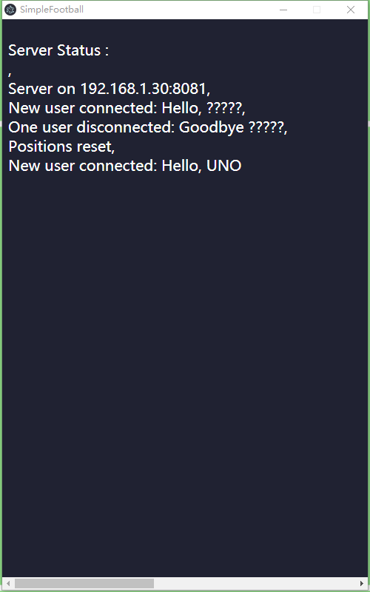

Figure : Server app



Figure : Start listening port & Get IPv4 address

* In the third attempt, the headless Phaser game is running in the canvas of ‘server.html’. The Phaser 3 itself does not render any objects as usual, while the elements on HTML file can be accessed and created through Phaser 3 and rendered by Electron renderer process. In which case, ‘Phaser. GameObjects. DOMElement’ class is introduced to create an instance for controlling a specific HTML element to display server status. The server status messages are stored as an array with limited capacity, and showed via ‘array_print()’ function. For example, the application window can display the IP address and the port of the server with assistance of ‘gameLoaded()’ function, as well as the game status on server. The detailed exhibition of showing the server message in an Electron message is shown on the right.



Figure : DOMElement instance from Phaser 3

* + 1. Packaged application



Figure : The file structure of packaged application

By using the ‘electron-packager’ framework with default configuration, the finished application was packaged into a native desktop program that can be run through opening the ‘SimpleFootball.exe’, and access the clients with any modern web browser across platforms. The file structure is shown on the right.

* + 1. Issues

Although the packaged application massively reduces the effort on operating the server, the size of either the executable or original folder is too big due to the complete Chromium rendering engine and the NodeJS runtime come with Electron. The original source files occupy 179 MB, while the size of the packaged application takes 214 MB, which is acceptable but not ideal for a distributable Windows-specific desktop program. Using electron-builder, which is an alternative packaging tool for Electron, can gain a much smaller installation package, but asking users to install the server application is less convenient than a click-and-start program.

Meanwhile, the server notifications constructed with the DOMElement instance from Phaser 3 let monitoring server status easier, but the limitation on creating and controlling DOM element through Phaser 3 methods makes it hard to continuing to enhance the layout in the main window of the Electron application. For example, the HTML element cannot be controlled by internal or external scripts other than Phaser 3 methods, which leads to the restriction on stored server messages as all statuses are not possible to show on the screen together without an auto-scroll-down scrollbar that is only possible with original DOM methods.

The most serious issue in the third attempt is having the computation of server data and rendering placed in one process, which may affect responding client’s request or even losing client’s message when enduring heavy load. It is caused by mixing the Phaser 3 instances with Socket.IO events and using the Phaser-running HTML file as the main page of the Electron application, which results in putting all rendering elements and main server content together. One possible solution is to run a welcome page responsible for showing server status messages in the main window, while an invisible vice window running the server transmits messages across the processes. Whether it is the worthy compensation for not sending message between different windows within Electron application to avoid more potential bugs and save developing time still need to be examined in further project.

1. Evaluation
   1. Usability test

For the purpose of evaluating the performance and accessibility of constructed application, including the server and the client, a usability test was made. The test revolved around the experiences on game notification, gameplay, NPC performance, multiplayer performance, server start-up and server performance. Thirteen testers are invited to the usability test due to current limitation, and the tests were done online for the same reason.

* + 1. Test method

At the beginning, each tester received a compressed repository that contained one folder named “SimpleFootball” including a complete application with necessary node modules preinstalled, an installation package of NodeJS in version 12.16.3, and a “readme.txt” file that stored all instructions. Testers were requested to read the text file first before they start the test. The detailed instructions will be provided in the appendix, and the general test content consist of installing and starting the server, running the client with a web browser, and playing the game until three goals were earned. During this phase, the testers were able to ask for help if technical problems, like errors and glitches, or incomprehensible instructions were met and could not be solved by themselves. After all requirement was fulfilled, the tester would receive a questionnaire that had eighteen multiple choices questions and two short answer questions, whose entire questions are attached at the end of this thesis. The usability test was over when the tester finished all questions and sent the questionnaire back. Some additional questions were asked according to the answers of questionnaire for more detailed information.



Figure : The file structure of ‘UsabilityTest’ compressed folder

* + 1. Test Result

All thirteen participants who took the test are now in their senior year, and seven of them are studying information technology related subjects as their majors though only three people are familiar with NodeJS. Four testers are playing video game more on a desktop PC or a game console, while another four prefer games on mobile devices. Additionally, three of them spends close amount of time on both desktop and mobile games. And most of them trend to play the multiplayer games, such as mobile MOBA games and board games.

Figure : Tester Info

As for the experience on the soccer game, the average overall score is 4.4 on a five-point scale. The main reasons for the score are the approval of the idea of a cross-platform multiplayer game and smooth and convenient multiplayer experiences on different platforms. However, the notifications of the game are not distinct enough for users to have necessary information quickly, whose average score is 3.4 with two lowest scores which are two points. The performances on gameplay, NPC and multiplayer scored 4 points and above that no tester thought they were bad during the game time. Three testers found observably glitches caused by Arcade Physics during the test, while only two persons felt possible network issues that not effected playing the game.

Figure : Game rating

On the contrast, the test results on server installation and start-up were not satisfied, even though no serious issue that would affect the game on client happened during the test. The average scores for installing server and starting server are 2.6 and 2.8, which could be blamed on the operation with command prompt, and both got a lowest score on one point. One problem worth referring is a loading error which was caused by the Chinese characters in file path, and was solved easily by removing illegal characters.

Figure : Server rating

Opinions from the testers in question twelve and twenty have shown some suggestion on the improvement of the game. The most frequently mentioned one is the improvement on using the server, as the command-line interface is not a common tool for experienced PC user. Most opinions point out that having a designed UI for the server or a one-click-start server application can greatly reduce the effort on operating the command prompt. The second one is the optimization of the game instructions as well as game notification, since both are hard to notice during the game. Other opinions focus on the NPC performance or physics performance due to their occasionally glitching movements like “shooting own goal” or “dancing around the goal post”.

* + 1. Analysis

The results in last chapter indicate that the soccer game lacks the instructions or tutorials before starting, even if the gameplay is simple and interesting. Besides, the notification area is not eye-catching enough for users to notice the updated status, which could make them confused without being informed properly. Under these circumstances, the enhancement on UI should focus on adding detailed game introduction of the gameplay and the areas for game status information before starting the game, as well as highlighting the new game notification to draw users’ attention in case they miss it.

The performances of the NPC logic and the Arcade Physics are fine, but there are still some areas for improvement. On the one hand, the NPC can have more decisions on controlling the players instead of randomly picking a player and simply deciding to “attack” or “defend”. For example, the NPC can let the player to block the way between the opponent and football. On the other hand, the Arcade Physics can be replaced by Matter Physics to strengthen the simulation on realistic reactions thanks to the fully server-side physics calculation. The clients will not need to share more computing resources on physics as they just move images around during the game.

In addition, though the usability testers did not mention the missing winning condition and limitation on having only one game on server at a time as they only need to earn three goals with their roommate or alone, the winning condition and multiple game rooms are necessary. Meanwhile, an error log for recording errors automatically would be better than just showing them in web console or command line. Another minor improvement can be forcing the webpages to be displayed in landscape on mobile phones if auto-rotate setting is unused.

And most importantly, the server itself, or with the client’s files, extremely needs to be packaged into an individual application, which may probability be achieved by using specific NodeJS library, e.g. Electron. Running a separate application for server can not only simplify the operations on it, but also keep clients being accessed across platform via a web browser since the communication methods have a high chance to remain the same.

* + 1. Improvement

As mentioned in the last chapter, the application needs to package the server into a separate program to allow a much simpler way to operate on the server for inexperienced PC user. Under this circumstance, the third attempt was made to achieve that target, as well as improve the notification on server side. Detailed implementation has written in chapter 3.3.

1. Conclusion and Outlook
   1. Conclusion

The task of this thesis is to develop a cross-platform client-server architecture using HTML5 and NodeJS. Through three attempts on implementing a semi turned-based multiplayer soccer game with different NodeJS libraries and server structures in JavaScript, it can be concluded that client-server architecture with one exclusive programming language is more suitable for a cross-platform low-cost project that requires relatively large amount of calculation at the time of this thesis completed, especially the web applications based on modern HTML5-supported web browsers and a NodeJS-backend server.

The conclusion is supported by the following two results:

* As it was explained and performed at the start of the second attempt, moving client-side codes to the server is much easier when using only one programming language, which is JavaScript in this thesis. This feature, on the one hand, allows developers to extend the compatibility of clients by handing over the heavy load to the server, which is commonly much more powerful. On the other hand, developers have a high probability to reuse as much resources as possible to save developing time while the project remains almost the same to customers who use client programs only. It can be seen from the transformation on network communication methods between the first implementation and the second one, as well as the alteration on server architecture between the second and third one.
* Comparing the normal desktop applications using a peer-to-peer (P2P) architecture with the ones based on client-server architecture, P2P seems to be a more reliable and flexible network architecture due to the sharing resources and unnecessary central server. However, web applications based on modern web browsers have only few protocols to set up a two-way communication, which are WebSocket for client-server communication and WebRTC for peer-to-peer communication in this specific case. At present, WebRTC is a rather “young” protocols and lacks of diverse instructions and tutorials for the deployment comparing to WebSocket, though it will keep ameliorating in the future. As a result, the client-server architecture shows more stability and simplicity on web application now.
  1. Outlook

Both the second and third implementation of the application are usable for running a cross-platform multiple-user application on web browsers, while the distinction between them is the server runtime environment. The second application structure has no user interface except the command prompt, which is more suitable for running on a host server or a cloud platform since the user will not control the server start-up by themselves. While the third one is more favorable for users to start and monitor server by themselves, which is good for a LAN network test or entertainment.

The thesis has its limitation on comparing the WebRTC and WebSocket protocols due to the different developing progress between mature WebSocket-based Socket.IO framework and other new NodeJS environment frameworks based on WebRTC, which could lead to the bias on judging the advantages of client-server architecture. In addition, the heavy load on computation and the prevention on game cheating also probably stop thesis digging into the advantages and disadvantages analysis among various network structure. Under these circumstances, an enhancement can be made to fully analyze the architectures in distributing systems with relative frameworks based on HTML5 or NodeJS techniques.

As for the game itself, the performance of NPCs and physics engine can be improved by constructing with better ones since both computing data are fully processed in the server now.

Acknowledgements

I would like to express my gratitude to my supervisor, Mr. Fabio Anthony, who provided me with plenty of useful suggestions and ideas on the thesis, as well as some daily issues. It’s always a pleasure to talk to him.

I would like to thank Mrs. Lenka Kleinau, who spent her time on holding online meetings for thesis writing details during the pandemic.

I would like to thank all usability test applicants, who spent their time and effort to carry out the test with me.

References

|  |  |
| --- | --- |
| [1] | Node.js®, "Introduction to Node.js," OpenJS Foundation, 24 12 2019. [Online]. Available: https://nodejs.dev/learn. [Accessed 8 5 2020]. |
| [2] | Yannick, "Phaser 3 - Real-Time Multiplayer example with Physics," 15 3 2020. [Online]. Available: https://github.com/yandeu/phaser3-multiplayer-with-physics/blob/master/README.md. [Accessed 2 5 2020]. |
| [3] | R. Davey, "Making your first Phaser 3 game," Photon Storm Ltd., 20 2 2018. [Online]. Available: https://phaser.io/tutorials/making-your-first-phaser-3-game/part1. [Accessed 20 5 2020]. |
| [4] | Photon Storm Ltd., "Phaser - A fast, fun and free open source HTML5 game framework," Photon Storm Ltd., [Online]. Available: https://phaser.io/. [Accessed 9 5 2020]. |
| [5] | d. T. K. and S. , "Socket.IO — Docs," Automattic, 17 4 2020. [Online]. Available: https://socket.io/docs/. [Accessed 19 5 2020]. |
| [6] | "jsdom," jsdom, 9 1 2020. [Online]. Available: https://github.com/jsdom/jsdom/blob/master/README.md. [Accessed 26 5 2020]. |
| [7] | "node-canvas," Automattic, 27 4 2020. [Online]. Available: https://github.com/Automattic/node-canvas/blob/master/Readme.md. [Accessed 16 5 2020]. |
| [8] | Node.js®, "Node.js v14.3.0 Documentation: Path," Node.js®, 23 5 2020. [Online]. Available: https://nodejs.org/api/path.html. [Accessed 24 5 2020]. |
| [9] | H. Santana, "datauri: Module and CLI to generate Data URI scheme.," 12 12 2016. [Online]. Available: https://github.com/data-uri/datauri/blob/master/readme.md. [Accessed 26 5 2020]. |
| [10] | Electron, "Writing Your First Electron App," GitHub, Inc., 3 2 2020. [Online]. Available: https://www.electronjs.org/docs/tutorial/first-app. [Accessed 28 5 2020]. |
| [11] | M. Lee, "Electron Packager," GitHub Inc., 26 5 2020. [Online]. Available: https://github.com/electron/electron-packager/blob/master/README.md. [Accessed 28 5 2020]. |
| [12] | Node.js®, "Node.js v14.3.0 Documentation: OS," Node.js®, 26 5 2020. [Online]. Available: https://nodejs.org/api/os.html. [Accessed 28 5 2020]. |
| [13] | l. M. and K. Boudot, "Matter.js is a JavaScript 2D rigid body physics engine for the web," 15 9 2019. [Online]. Available: https://brm.io/matter-js/. [Accessed 14 5 2020]. |
| [14] | C. Jennings, H. Boström and J.-I. Bruaroey, "WebRTC 1.0: Real-time Communication Between Browsers," W3C Candidate Recommendation, 13 12 2019. [Online]. Available: https://www.w3.org/TR/webrtc/. [Accessed 14 5 2020]. |
| [15] | P. Sletvold, "Running Phaser 3 on the server," 4 4 2018. [Online]. Available: https://medium.com/@16patsle/running-phaser-3-on-the-server-4c0d09ffd5e6. [Accessed 28 4 2020]. |
| [16] | S. Westover, "Creating A Simple Multiplayer Game In Phaser 3 With An Authoritative Server – Part 1," 16 1 2019. [Online]. Available: https://phasertutorials.com/creating-a-simple-multiplayer-game-in-phaser-3-with-an-authoritative-server-part-1/. [Accessed 28 4 2020]. |
| [17] | Y. Tay, "tree-node-cli," 5 4 2020. [Online]. Available: https://www.npmjs.com/package/tree-node-cli. [Accessed 26 5 2020]. |

Appendix

List of Figures

[Figure 1: The football field 14](https://d.docs.live.net/52a437b33a87089d/Documents/TH%20Luebeck/BA%20Thesis/BA%20Thesis_ver%200.1.2.docx#_Toc41927342)

[Figure 2: The total UI 14](https://d.docs.live.net/52a437b33a87089d/Documents/TH%20Luebeck/BA%20Thesis/BA%20Thesis_ver%200.1.2.docx#_Toc41927343)

[Figure 3: The goal animation 14](https://d.docs.live.net/52a437b33a87089d/Documents/TH%20Luebeck/BA%20Thesis/BA%20Thesis_ver%200.1.2.docx#_Toc41927344)

[Figure 4 The file structure of chat room app 15](https://d.docs.live.net/52a437b33a87089d/Documents/TH%20Luebeck/BA%20Thesis/BA%20Thesis_ver%200.1.2.docx#_Toc41927345)

[Figure 5: Codes for transmitting images 16](https://d.docs.live.net/52a437b33a87089d/Documents/TH%20Luebeck/BA%20Thesis/BA%20Thesis_ver%200.1.2.docx#_Toc41927346)

[Figure 6: Codes for Ajax method 16](https://d.docs.live.net/52a437b33a87089d/Documents/TH%20Luebeck/BA%20Thesis/BA%20Thesis_ver%200.1.2.docx#_Toc41927347)

[Figure 7: Chat room layout 16](https://d.docs.live.net/52a437b33a87089d/Documents/TH%20Luebeck/BA%20Thesis/BA%20Thesis_ver%200.1.2.docx#_Toc41927348)

[Figure 8: Time gaps 16](https://d.docs.live.net/52a437b33a87089d/Documents/TH%20Luebeck/BA%20Thesis/BA%20Thesis_ver%200.1.2.docx#_Toc41927349)

[Figure 9: Current game UI status 17](https://d.docs.live.net/52a437b33a87089d/Documents/TH%20Luebeck/BA%20Thesis/BA%20Thesis_ver%200.1.2.docx#_Toc41927350)

[Figure 10: Two coordinates from two clients 17](https://d.docs.live.net/52a437b33a87089d/Documents/TH%20Luebeck/BA%20Thesis/BA%20Thesis_ver%200.1.2.docx#_Toc41927351)

[Figure 11: The file structure of the first attempt 19](https://d.docs.live.net/52a437b33a87089d/Documents/TH%20Luebeck/BA%20Thesis/BA%20Thesis_ver%200.1.2.docx#_Toc41927352)

[Figure 12: Required modules 19](https://d.docs.live.net/52a437b33a87089d/Documents/TH%20Luebeck/BA%20Thesis/BA%20Thesis_ver%200.1.2.docx#_Toc41927353)

[Figure 13: Define file path for client 19](https://d.docs.live.net/52a437b33a87089d/Documents/TH%20Luebeck/BA%20Thesis/BA%20Thesis_ver%200.1.2.docx#_Toc41927354)

[Figure 14: The properties of ‘users’ 20](https://d.docs.live.net/52a437b33a87089d/Documents/TH%20Luebeck/BA%20Thesis/BA%20Thesis_ver%200.1.2.docx#_Toc41927355)

[Figure 15: Compute the shooting angle in different conditions 22](https://d.docs.live.net/52a437b33a87089d/Documents/TH%20Luebeck/BA%20Thesis/BA%20Thesis_ver%200.1.2.docx#_Toc41927356)

[Figure 16: Compute final output velocity with trigonometric functions 22](https://d.docs.live.net/52a437b33a87089d/Documents/TH%20Luebeck/BA%20Thesis/BA%20Thesis_ver%200.1.2.docx#_Toc41927357)

[Figure 17: The file structure of ‘public’ folder 23](https://d.docs.live.net/52a437b33a87089d/Documents/TH%20Luebeck/BA%20Thesis/BA%20Thesis_ver%200.1.2.docx#_Toc41927358)

[Figure 18: Login Page 23](https://d.docs.live.net/52a437b33a87089d/Documents/TH%20Luebeck/BA%20Thesis/BA%20Thesis_ver%200.1.2.docx#_Toc41927359)

[Figure 19: Game Page 23](https://d.docs.live.net/52a437b33a87089d/Documents/TH%20Luebeck/BA%20Thesis/BA%20Thesis_ver%200.1.2.docx#_Toc41927360)

[Figure 20: Phaser game configuration 24](https://d.docs.live.net/52a437b33a87089d/Documents/TH%20Luebeck/BA%20Thesis/BA%20Thesis_ver%200.1.2.docx#_Toc41927361)

[Figure 21: The file structure of SimpleFootball app 26](https://d.docs.live.net/52a437b33a87089d/Documents/TH%20Luebeck/BA%20Thesis/BA%20Thesis_ver%200.1.2.docx#_Toc41927362)

[Figure 22 Required modules 26](https://d.docs.live.net/52a437b33a87089d/Documents/TH%20Luebeck/BA%20Thesis/BA%20Thesis_ver%200.1.2.docx#_Toc41927363)

[Figure 23 Use JSDOM to make up missed methods 27](https://d.docs.live.net/52a437b33a87089d/Documents/TH%20Luebeck/BA%20Thesis/BA%20Thesis_ver%200.1.2.docx#_Toc41927364)

[Figure 24: The file structure of ‘physic_structure’ folder 27](https://d.docs.live.net/52a437b33a87089d/Documents/TH%20Luebeck/BA%20Thesis/BA%20Thesis_ver%200.1.2.docx#_Toc41927365)

[Figure 25: Variables for storing status 28](https://d.docs.live.net/52a437b33a87089d/Documents/TH%20Luebeck/BA%20Thesis/BA%20Thesis_ver%200.1.2.docx#_Toc41927366)

[Figure 26: Object for synchronization 29](https://d.docs.live.net/52a437b33a87089d/Documents/TH%20Luebeck/BA%20Thesis/BA%20Thesis_ver%200.1.2.docx#_Toc41927367)

[Figure 27: Array structure of the position 29](https://d.docs.live.net/52a437b33a87089d/Documents/TH%20Luebeck/BA%20Thesis/BA%20Thesis_ver%200.1.2.docx#_Toc41927368)

[Figure 28 The file structure of ‘public’ folder 29](https://d.docs.live.net/52a437b33a87089d/Documents/TH%20Luebeck/BA%20Thesis/BA%20Thesis_ver%200.1.2.docx#_Toc41927369)

[Figure 29: The file structure of SimpleSoccer app 31](https://d.docs.live.net/52a437b33a87089d/Documents/TH%20Luebeck/BA%20Thesis/BA%20Thesis_ver%200.1.2.docx#_Toc41927370)

[Figure 30: Electron application configuration (index.js) 31](https://d.docs.live.net/52a437b33a87089d/Documents/TH%20Luebeck/BA%20Thesis/BA%20Thesis_ver%200.1.2.docx#_Toc41927371)

[Figure 32: Server app 32](https://d.docs.live.net/52a437b33a87089d/Documents/TH%20Luebeck/BA%20Thesis/BA%20Thesis_ver%200.1.2.docx#_Toc41927372)

[Figure 31: Start listening port & Get IPv4 address 32](https://d.docs.live.net/52a437b33a87089d/Documents/TH%20Luebeck/BA%20Thesis/BA%20Thesis_ver%200.1.2.docx#_Toc41927373)

[Figure 33: DOMElement instance from Phaser 3 33](https://d.docs.live.net/52a437b33a87089d/Documents/TH%20Luebeck/BA%20Thesis/BA%20Thesis_ver%200.1.2.docx#_Toc41927374)

[Figure 34: The file structure of packaged application 33](https://d.docs.live.net/52a437b33a87089d/Documents/TH%20Luebeck/BA%20Thesis/BA%20Thesis_ver%200.1.2.docx#_Toc41927375)

[Figure 35: The file structure of ‘UsabilityTest’ compressed folder 35](https://d.docs.live.net/52a437b33a87089d/Documents/TH%20Luebeck/BA%20Thesis/BA%20Thesis_ver%200.1.2.docx#_Toc41927376)

[Figure 36: Tester Info 35](https://d.docs.live.net/52a437b33a87089d/Documents/TH%20Luebeck/BA%20Thesis/BA%20Thesis_ver%200.1.2.docx#_Toc41927377)

[Figure 37: Game rating 36](https://d.docs.live.net/52a437b33a87089d/Documents/TH%20Luebeck/BA%20Thesis/BA%20Thesis_ver%200.1.2.docx#_Toc41927378)

[Figure 38: Server rating 36](https://d.docs.live.net/52a437b33a87089d/Documents/TH%20Luebeck/BA%20Thesis/BA%20Thesis_ver%200.1.2.docx#_Toc41927379)

Usability Test: Instructions

The instructions were written in the ‘readme.txt’ files contained in the ‘UasbilityTest’ compressed folder.

1. Unzip the compressed package under the path without Chinese characters.
2. Install the NodeJS: If you have not installed the Node.js® before or your NodeJS version is under 12, please double click ‘node-v12.16.3-x64.msi’ to install NodeJS. Please use default configuration during the installation in case any errors occur.
3. Open the command prompt: Press ‘win + R’, type in ‘cmd’ in pop-up “Run” application and click “OK”.
4. Find and write down local IP address: Type in ‘ipconfig’ on the command line and press ‘Enter’. Look for “IPv4 Address” in the section who has a “Connection-specific DNS Suffix” called “localdomain”. Record the IPv4 address. (For example: 192.168.1.30)
5. Navigate to ‘SimpleFootball’ folder: If the folder is not under local disk (C:), type in corresponding letter with a colon on the command line, and press ‘Enter’. For example, if the folder is under disk (D:), type in ‘d:’ or ‘D:’. Type in the path of the ‘SimpleFootball’ folder with a prefix ‘cd ’, and press ‘Enter’.

(For instance: ‘cd D:\GitHub\BachelorThesis\SimpleFootball’)

1. Enter ‘node server/server.js’ on the command line. If Windows asks for a permission on network, allow NodeJS to do following process to proceed. Wait until “Phaser [……] Listening on 8081” shows in the command prompt.
2. Open the client with a web browser (except IE): Open your web browser on cellphone or desktop. Type in ‘your IPv4 address:8081‘ in the URL bar, such as ‘192.168.1.30:8081’. The webpage should show up in a few seconds.
3. Enter your nickname and start the game. Keep playing until you earn 3 goals.
4. Reply me when you finish step 8. A questionnaire will be sent, and needs to be filled and sent back to me in any format.
5. If you meet any issues that cannot be solved alone, please contact me as soon as possible.

Usability Test: Questionnaire

1. Your gender:

|  |  |  |
| --- | --- | --- |
| 🞏 Male. | 🞏 Female. | 🞏 Other. |

1. Your age:

|  |  |  |  |
| --- | --- | --- | --- |
| 🞏 < 18 | 🞏 18-22 | 🞏 22-26 | 🞏 > 26 |

1. Do you often play video games?

|  |  |  |
| --- | --- | --- |
| 🞏 Yes, often on a desktop PC or a game console. | | 🞏 Yes, often on mobile devices. |
| 🞏 Yes, on both sides. | 🞏 No, not often. | 🞏 Never. |

1. Which kind of game do you play most?

|  |  |  |
| --- | --- | --- |
| 🞏 Multiplayer games. | 🞏 Single-player game. | 🞏 I don’t play games. |

1. How clear is the notification of the game?

|  |  |  |  |  |
| --- | --- | --- | --- | --- |
| 🞏 1 (very bad) | 🞏 2 (bad) | 🞏 3 (average) | 🞏 4 (good) | 🞏 5 (very good) |

1. How easy is it to control the player?

|  |  |  |  |  |
| --- | --- | --- | --- | --- |
| 🞏 1 | 🞏 2 | 🞏 3 | 🞏 4 | 🞏 5 |

1. How well did NPC perform during the game?

|  |  |  |  |  |
| --- | --- | --- | --- | --- |
| 🞏 1 | 🞏 2 | 🞏 3 | 🞏 4 | 🞏 5 |

1. How is experience on multiplayer?

|  |  |  |  |  |
| --- | --- | --- | --- | --- |
| 🞏 1 | 🞏 2 | 🞏 3 | 🞏 4 | 🞏 5 |

1. Did glitch exist during the game?

|  |  |
| --- | --- |
| 🞏 Yes, it effected game seriously. | 🞏 Yes, but it disappeared later. |
| 🞏 Maybe, I don’t notice it. | 🞏 No, I never saw it. |

1. Did network problem exist during the game?

|  |  |
| --- | --- |
| 🞏 Yes, it effected game seriously. | 🞏 Yes, but it disappeared later. |
| 🞏 Maybe, I don’t notice it. | 🞏 No, I never saw it. |

1. Overall score on game:

|  |  |  |  |  |
| --- | --- | --- | --- | --- |
| 🞏 1 | 🞏 2 | 🞏 3 | 🞏 4 | 🞏 5 |

1. Any opinion towards the game?

|  |
| --- |
|  |

1. Is your major related to Information Technology?

|  |  |  |
| --- | --- | --- |
| 🞏 Yes. | 🞏 No. | 🞏 No, but I’ve learned programming by myself. |

1. Are you familiar with Node.js®?

|  |  |
| --- | --- |
| 🞏 Yes. | 🞏 No. |

1. How convenient it is to install the sever?

|  |  |  |  |  |
| --- | --- | --- | --- | --- |
| 🞏 1 | 🞏 2 | 🞏 3 | 🞏 4 | 🞏 5 |

1. How convenient it is to start the sever?

|  |  |  |  |  |
| --- | --- | --- | --- | --- |
| 🞏 1 | 🞏 2 | 🞏 3 | 🞏 4 | 🞏 5 |

1. Did error occur during the running period?

|  |  |
| --- | --- |
| 🞏 Yes, it effected game seriously. | 🞏 Maybe, I don’t notice it. |
| 🞏 No, I never saw it. |  |

1. Can you provide detailed error message?

|  |  |  |
| --- | --- | --- |
| 🞏 Yes, | 🞏 No. | 🞏 I have no error. |

1. Was it solved?

|  |  |
| --- | --- |
| 🞏 Yes, it was solved after restart. | 🞏 No. |
| 🞏 Yes, it was solved by following other’s instructions. | 🞏 I have no error. |

1. Any opinion towards the server?

|  |
| --- |
|  |